**“PREDICTION OF EMPLOYEE ATTRITION”**

**Major project- II report**

***Submitted by:-***

**Name: Aditi Tiwari**  **Enrollment no. 0206CD211011**

**Name: Aanya Singhai**  **Enrollment no. 0206CD211003**

**Name: Anshika Gupta**  **Enrollment no. 0206CD211020**

**Name: Jagrati Yadav**  **Enrollment no. 0206CD211033**

***in partial fulfillment for the award of the degree***

***of***

**BACHELOR OF TECHNOLOGY**

***in***

**COMPUTER SCIENCE ENGINEERING – DATA SCIENCE**



**DEPARTMENT OF CSE - DATA SCIENCE**

GYAN GANGA INSTITUTE OF TECHNOLOGY & SCIENCES

JABALPUR (M.P.)

RAJIV GANDHI PRODYOGIKI VISHWAVIDYALAYA,

BHOPAL (M.P.)

**June - 2025**

#### *CERTIFICATE*

This is to certify that the Major Project Report entitled “**PREDICTION OF EMPLOYEE ATTRITION**” submitted by **Aditi Tiwari, Anshika Gupta , Aanya Singhai and Jagrati Yadav** has been carried out under my guidance & supervision. The project report is approved for submission towards partial fulfillment of the requirement for the award of the degree of **BACHELOR OF TECHNOLOGY** in **CSE-DATA SCIENCE** from **RAJIV GANDHI PROUDYOGIKI VISHWA-VIDYALAYA, BHOPAL (M.P)**

|  |  |
| --- | --- |
| **Prof Juhi Jain**  **Guide**  **Dept. of Computer Science and Engineering**  **(**DATA SCIENCE**)** | **Dr. Bhavana Jain**  **Head Coordinator**  **Dept. of Computer Science and Engineering**  **(**DATA SCIENCE**)**  **Dr. Ashok Kumar Verma**  **Dean**  **Dept. of Computer Science and Engineering**  **(**DATA SCIENCE**)** |

#### *CERTIFICATE*

This is to certify that the Major Project Report entitled “**PREDICTION OF EMPLOYEE ATTRITION**” is submitted by **Aditi Tiwari, Anshika Gupta , Aanya Singhai and Jagrati Yadav** for the partial fulfillment of the requirement for the award of degree of **BACHELOR OF TECHNOLOGY** in **CSE–DATA SCIENCE** from **RAJIV GANDHI PROUDYOGIKI VISHWAVIDYALAYA, BHOPAL (M.P).**

Internal Examiner External Examiner

Date: Date:

# 

# 

#### *DECLARATION*

We hereby declare that the project report entitled **“Prediction of Employee Attrition ”** which is being submitted in partial fulfillment of the requirement for award of the Degree of Bachelor of Engineering in Computer Science and Engineering with Data Science Specialization to **“RAJIV GANDHI PROUDYOGIKI VISHWAVIDYALAYA, BHOPAL (M.P.)”** is an authentic record of our own work done under the guidance of Prof. Juhi Jain **Department of CSE-DATA SCIENCE,** **GYAN GANGA INSTITUTE OF TECHNOLOGY & SCIENCES, JABALPUR**.

The matter reported in this report has not been submitted earlier for the award of any other degree.

**Date:**

**Place: JABALPUR**

#### *ACKNOWLEDGEMENT*

We sincerely express indebtedness to the esteemed and revered guide

Prof. Juhi Jain **of the Department of Computer Science Engineering-Data Science** *for* his invaluable guidance, supervision, and encouragement throughout the work. Without his kind patronage and guidance, the synopsis would not have taken shape.

We take this opportunity to express a deep sense of gratitude to **Dr Bhavna Jain, Head Coordinator of CSE-Data science** and **Dr. Ashok Kumar Verma, Dean of Computer Science and Engineering,**for his encouragement and kind approval. Also, we thank him for providing the computer lab facility. We would like to express our sincere regards to him for advice and counseling from time to time.

We owe sincere thanks to all the faculties in the Department of Computer Science and Engineeringfor their advice and counseling time to time.

**Date :**

##### **Place : JABALPUR**

Aditi Tiwari 0206CD211011

Aanya Singhai 0206CD211003

Anshika Gupta 0206CD211020

Jagrati Yadav 0206CD211033

|  |  |  |  |  |  |  |  |  |  |  |  |  |  |  |  |  |  |  |  |  |  |  |  |  |  |  |  |  |  |  |  |  |  |  |  |  |  |  |  |  |  |  |  |  |  |  |  |  |  |  |  |  |  |  |  |  |  |  |  |  |  |  |  |  |  |  |  |  |  |  |  |  |  |  |
| --- | --- | --- | --- | --- | --- | --- | --- | --- | --- | --- | --- | --- | --- | --- | --- | --- | --- | --- | --- | --- | --- | --- | --- | --- | --- | --- | --- | --- | --- | --- | --- | --- | --- | --- | --- | --- | --- | --- | --- | --- | --- | --- | --- | --- | --- | --- | --- | --- | --- | --- | --- | --- | --- | --- | --- | --- | --- | --- | --- | --- | --- | --- | --- | --- | --- | --- | --- | --- | --- | --- | --- | --- | --- | --- |
|  | **TABLE OF CONTENTS**   |  |  |  | | --- | --- | --- | | **Serial No.** | **Title Page No.** | **Page No.** | |  | ABSTRACT 9 | 1 | | **1.** | **INTRODUCTION 9** | 2 | |  | * 1. Purpose of Project 9   1.2 Scope of the Project 9 | 3 | |  | * 1. Project and Product Overview 9 | 4 | |  | * 1. Designs Goals 11   1.5 Intended Audience 16 | 4 | |  | 1.6 Team Architecture 18  1.7 Survey of Technology 19  1.8 Overall Description 19  1.9Project Modules and Timeline 20 | 4 | | **2.** | **PROBLEM STATEMENT 21** | 9 | |  | 2.1 Selection of Product 21 | 9 | |  | 2.2 System Requirement 21 | 9 | |  | 2.3 Existing System 22 | 9 | |  | 2.4 Drawbacks of Existing System 22 | 9 | |  | 2.5 Proposed System 23 | 10 | |  | 2.6 Advantages of Proposed System 23 | 10 | |  | 2.7 Limitations of Proposed System 23  2.8 Application 24 | 10 | | **3.** | **SPECIFIC REQUIREMENTS 25** |  | |  | 3.1 User Interface 25  3.2 Hardware Interface 26  3.3 Software Interface 26  3.4 Communication Interface 27  3.5 Non functional Requirements 27  3.6 Software System Attributes 28 | 12 | | **4.** | **SOFTWARE PROCESS MODEL 29**  4.1 Determining project feasibility 29 | 14 | | **5.** | **Overall Implementation Design 30**  5.1 About The Front End  5.2 About The Back End |  | | **6.** | **LIST OF FIGURES 31-36**  6.1 List of figures 31-36 |  | | **7.** | **Future Enhancements 37** |  | | **8.** | **Result 38** |  | | **9.** | **Conclusion 39** |  | | **10.** | **References 40** |  | |  |
|  | ***LIST OF FIGURES*** |  |
|  | |  |  |  | | --- | --- | --- | | **S.No** | **Figure Name** | **Page No.** | | 5.2 | Use case diagram | 31 | | 5.3 | Sequence diagram | 32 | | 5.4 | Login diagram | 33 | | 5.5 | Data flow diagram level 0 | 35 | | 5.6 | Data flow diagram level 1 | 35 | | 5.7 | Activity diagram | 36 | |  |

**ABSTRACT**

Employee attrition, the departure of employees from an organization, poses a significant challenge for businesses. This study aims to predict employee attrition using advanced machine learning techniques. By analyzing various factors such as job satisfaction, work-life balance, compensation, and tenure, we aim to identify key indicators that contribute to attrition. Through the application of techniques like logistic regression, decision trees, and random forests, we seek to develop accurate predictive models. These models can empower organizations to proactively address potential attrition risks, implement retention strategies, and ultimately enhance employee satisfaction and overall organizational performance.

# 1.Introduction

## 1.1Purpose Of The Project

The purpose of a project that predicts employee attrition (when employees leave a company) is to help businesses understand why employees might leave and when it could happen. This allows the company to take action to improve employee satisfaction, reduce turnover, and retain valuable staff. By predicting attrition, the company can make better decisions about hiring, training, and improving workplace culture to keep employees happy and engaged.

**1.2 Scope of the project**

## Scope of Employee Attrition Prediction

## The primary goal of employee attrition prediction is to develop a model that can accurately identify employees who are likely to leave an organization. By understanding the factors influencing attrition, organizations can implement proactive strategies to retain valuable talent.

## Project And Product Overview

Employee Attrition Prediction

* Goal: Predict which employees are likely to quit.

* How: Uses machine learning to analyze employee data (like salary, work hours, job satisfaction).

* Benefits:

* Reduce costs of losing employees.

* Improve employee retention.

* Better plan for future workforce needs.

* Make data-driven decisions about HR policies.

In essence, it's like a "quitting risk" scorecard for employees, helping companies proactively keep their best talent.

**1.4 Design Goals**

1. Admin Login  
   The Admin logs into the system by entering their personal credentials, such as ID and password, to access the system's database.
2. About Us  
   Employees can view details about the application, including its purpose, mission, and vision.
3. Contact Us  
   This page provides users with the contact details of the developers or administrators responsible for the system.
4. Search Employee Details  
   Admins can search for specific employees and view their details, such as performance metrics, work history, and feedback.
5. Attrition Prediction  
   The system predicts the likelihood of an employee leaving based on various factors such as performance, engagement levels, and work history, providing actionable insights to the admin.
6. Career Growth Analysis  
   The system suggests career development opportunities and growth plans for employees based on their skillsets and performance trends.
7. Retention Strategy Suggestions  
   The system provides strategies or action plans to retain employees at risk of attrition, such as personalized training programs or incentives.
8. Feedback Collection  
   Employees can submit feedback or raise concerns in the feedback section. This input is analyzed and reported to the admin for improving work culture.
9. News & Updates  
   This section provides employees and admins with the latest updates, such as organizational news, HR policies, and research on employee engagement.
10. Log Out  
    Admin securely logs out of the system to ensure data protection.
    1. **Intended Audience**

The intended audience for employee attrition prediction includes HR professionals, executives, and team leaders who can use these insights to improve retention strategies. Additionally, data scientists and researchers benefit from analyzing factors influencing turnover.

The SRS document aims to explain in an easy manner, the basic idea behind the  project and how the professionals  aim to achieve their goals.

* 1. **Team Architecture**

The team consists of 4 members:

1. Aditi Tiwari
2. Anshika Gupta
3. Aanya Singhai
4. Jagrati Yadav

**REQUIREMENT GATHERING AND ANALYSIS**

This is the initial and most crucial step of the project. Accurate requirement gathering and analysis ensure the success of the project.

* The process involves collecting details about factors influencing employee attrition from stakeholders and analyzing relevant data.
* This step will also define key metrics, such as job satisfaction, performance ratings, and work-life balance, to be included in the model.
* The main output of this phase is a detailed **System Requirements Specification (SRS)** document to guide further development.

**DESIGNING PART - 1**

This phase focuses on preparing the system’s database and data flow models:

1. Develop an **E-R (Entity-Relationship) Model** to represent data entities like employees, performance, and organizational details, along with their relationships.
2. Translate the E-R model into a **Relational Model** to structure data for the database.
3. Create the **Database Tables** to store employee data, historical attrition trends, and predictions.

**CODING PART – 1**

This phase involves implementing the design into a functional system:

1. **Frontend Development**:
   * Build a user-friendly GUI using **HTML**, **CSS**, and optionally **JavaScript**.
   * Create modules for Admin Login, Data Upload, and Prediction Results.
2. **Backend Development**:
   * Develop APIs and algorithms to handle data processing and integrate the prediction model.
   * Use Python with libraries like **Pandas**, **Scikit-learn**, or **TensorFlow** to create the machine learning model for attrition prediction.
3. **Core Modules**:
   * Admin Login: For secure access.
   * Prediction Module: Takes employee data as input and predicts attrition risk.
   * Report Generation: Summarizes attrition trends and provides actionable insights.

This framework ensures the project is manageable, focused, and aligned with its objectives. Let me know if further refinement is needed!

**1.7 Survey Of Technology**

The basic elements that helped to make better software are mentioned below:

* Ensemble learning.
* Python
* Machine Learning
* Designing Tool: Wondershare Edrawmax

1.7.1. Ensemble learning:

Ensemble learning is a method in machine learning where we use several models together to get better predictions than any single model alone. Imagine trying to make a big decision: if you ask multiple people for their opinions, you’ll get a more balanced answer than just asking one person. Ensemble learning works in a similar way by combining the "opinions" of different models.

1.7.2.PYTHON:

Python is an interpreted, object-oriented, high-level programming language with dynamic semantics developed by Guido van Rossum. It was originally released in 1991. Designed to be easy as well as fun, the name "Python" is a nod to the British comedy group Monty Python. Python has a reputation as a beginner-friendly language, replacing Java as the most widely used introductory language because it handles much of the complexity for the user, allowing beginners to focus on fully grasping programming concepts rather than minute details. Python is used for server-side web development, software development, mathematics, and system scripting, and is popular for Rapid Application Development and as a scripting or glue language to tie existing components because of its high-level, built-in data structures, dynamic typing, and dynamic binding. Program maintenance costs are reduced with Python due to the easily learned syntax and emphasis on readability.

Additionally, Python's support of modules and packages facilitates modular programs and reuse of code. Python is an open source community language, so numerous independent programmers are continually building libraries and functionality for it.

1.7.3.MACHINE LEARNING:

There are several uses for machine learning, including speech and picture recognition, natural language processing, fraud detection, portfolio optimisation, automated tasks, and many more. Robots, drones, and autonomous vehicles are all powered by machine learning models, which give them more intelligence and environmental adaptability.

Making recommendations is a common machine learning problem. Machine learning is frequently used in recommender systems, which use previous data to provide consumers customised recommendations. In the case of Netflix, the system makes movie and TV programmes recommendations to users based on their watching history, ratings, and additional characteristics like genre preferences using a combination of collaborative filtering and content-based filtering.

1.7.4.DESIGNING TOOL: WONDERSHARE EDRAWMAX:

A robust, all-in-one, and simple-to-use diagramming tool, EdrawMax enables users to quickly and easily visualise their ideas. Flowcharts, Venn diagrams, mind maps, organisational charts, Gantt charts, UML diagrams, electrical drawings, genograms, architectural plans, and more can all be made with EdrawMax.

Both professionals and amateurs may create diagrams with a professional appearance using EdrawMax's cutting-edge features. It should be a great Visio replacement that allows you to generate more than 280 different types of diagrams. Users of any skill level may get started with ease thanks to powerful toolkits and a very user-friendly UI.

**TIER ARCHITECTURE.**

The various classes as obtained from the business class diagram is categorized as follows-

|  |  |  |  |  |
| --- | --- | --- | --- | --- |
| **Form of the project** |  | **Class** |  | **Class** |
| Application or Presentation Layer |  | **Business Layer or Logical Layer** |  | **Data Layer or Data Access Layer** |

The 3 tier architecture consists of three layers:

**Presentation Layer** - The web site or windows forms application is called the presentation layer. The presentation layer is the most important layer simply because it’s the one that everyone sees and uses. Even with a well structured business and data layer, if the presentation layer is designed poorly, this gives the users a poor view of the system. Presentation layer is the form where we design using the controls like textbox, labels, command buttons etc.

**Business Layer** - Though a web site could talk to the data access layer directly, it usually goes through another layer called the business layer.

This layer is a class which we use to write the function which works as a mediator to transfer the data from Application or presentation layer data layer. In the three tier architecture we never let the data access layer to interact with the presentation layer.

This layer is also a class where we declare the variable corresponding to the fields of the database which can be required for the application and make the properties so that we can get or set the data using these properties into the variables. These properties are public so that we can access its values.

One of the best reasons for reusing logic is that applications that start off small usually grow in functionality. For instance, a company begins to develop a web site, and as they realize their business needs, they later decide to add a smart client application and windows service to supplement the web site. The business layer helps move logic to a central layer for “maximum reusability.”

Business layer have been presented having two roles

* client application
* server component

**EXAMPLE OF BUSINESS LAYER**

The Business layer has functions of which takes the parameters from the example given in the presentation layer .As the user inputs the data values, corresponding functions are called in the business layer and corresponding procedures are called and the data is been updated.

Business layer is the class where we write the functions which get the data from the application layer and passes through the data access layer.

**Data layer** - The key component to most applications is the data. The data has to be served to the presentation layer somehow. The data layer is a separate component whose sole purpose is to serve up the data from the database and return it to the caller. This layer is also a class which we use to get or set the data to the database back and forth. This layer only interacts with the database. We write the database queries or use stored procedures to access the data from the database or to perform any operation to the database.

**ADVANTAGE OF 3 TIER ARCHITECTURE**

* Client-Server architecture is 2-Tier architecture because the client does not distinguish between Presentation layer and business layer.
* The increasing demands on GUI controls caused difficulty to manage the mixture of source code from GUI and Business Logic .
* Further, Client Server Architecture does not support enough the Change Management. Let suppose that the government increases the Entertainment tax rate from 4% to 8 %, then in the Client-Server case, we have to send an update to each clients and they must update synchronously on a specific time otherwise we may store invalid or wrong information.
* The Client-Server Architecture is also a burden to network traffic and resources. Let us assume that about five hundred clients are working on a data server then we will have five hundred ODBC connections and several ruffian record sets, which must be transported from the server to the clients .
* This categorization of the application makes the function more reusable easily and it becomes too easy to find the functions which have been written previously. If programmer wants to make further update in the application then he easily can understand the previous written code and can update easily.

**DISADVANTAGES**

* Increase complexity /effort
* More difficult to built 3 tier architecture rather then a 2 tier.
* Points of communication are doubled
* Maintenance tools are currently inadequate for maintaining server libraries.

**1.8. Overall Description**

Predicting employee attrition is about understanding why employees leave a company and figuring out who might leave in the future. High employee turnover can be costly and disruptive, leading to extra expenses for hiring and training new employees, and losing valuable knowledge and experience. By analyzing employee data—such as job satisfaction, performance, and work-life balance—companies can identify patterns that indicate an employee might be at risk of leaving. This helps organizations take steps to improve employee retention, keep their teams stable, and reduce the costs and challenges associated with high turnover.

**1.9 Project Modules**

The system, **"Employee Attrition Prediction"**, consists of 4 modules:

The system, **"Employee Attrition Prediction"**, consists of 4 modules:

**1. Login Module:**

This module handles secure access to the system.

* The admin logs into the system using their email ID and password.
* Upon successful login, the admin can access the application and manage employee data.
* The admin can view predictions, generate reports, and update details.
* The system ensures that only authorized personnel can interact with sensitive data.

**2. Employee Profile Module:**

This module provides a detailed view of employee information.

* Admins can search for and view specific employee profiles, including job role, performance metrics, and satisfaction levels.
* The module allows the admin to update employee records, such as department, designation, or feedback.
* Admins can analyze employee history to understand factors influencing their attrition risk.

**3. Attrition Prediction Module:**

This module predicts the likelihood of an employee leaving the organization.

* Admin uploads employee data such as job satisfaction, performance ratings, and work-life balance metrics.
* The system analyzes this data using a machine learning model to calculate the attrition risk.
* Admins receive a detailed report with the attrition probability and suggestions to retain at-risk employees.
* This module helps HR teams proactively address employee concerns and reduce turnover.

**4. Insights and Suggestions Module:**

This module provides actionable recommendations based on the prediction outcomes.

1. **Retention Strategies:**
   * Suggests personalized plans for employees at risk of leaving, such as training opportunities, incentives, or mentorship programs.
2. **Trend Analysis:**
   * Provides visual insights (charts, graphs) on overall attrition trends, such as high-risk departments or factors influencing attrition.
3. **Employee Engagement Suggestions:**
   * Includes links and resources to improve engagement, such as:
     + Career growth tips.
     + Work-life balance activities.
     + Stress management workshops.

This module enables organizations to enhance their retention strategies and employee satisfaction proactively.

This structure ensures a systematic and practical approach to predicting and addressing employee attrition effectively. Let me know if additional customization is required!

**DURATION:**

The overall project took 120 days to complete.

|  |  |  |
| --- | --- | --- |
| **Sr. No** | **Project Phase** | **Phase Period (Working Days)** |
|  | Business Requirement Study | 12 |
|  | Low Level/Application Design | 22 |
|  | Development and Unit Testing | 30 |
|  | Test & Bug Fixing | 10 |
|  | Documentation | 10 |
|  | Deployment User Acceptance Testing | 10 |
|  | User Training/handover | 10 |
|  | Project Management | 20 |
|  | Total | 120 |

**2.Problem Statement:**

## Entry Point

The entry point for the employee attrition prediction project is the employee data that the company already has. This data typically includes information such as:

1.Personal Details: Age, gender, education, and job position.

2.Job-Related Information: Salary, job satisfaction, performance scores, work hours, and length of employment.

3.Work Environment: Company culture, opportunities for growth, and work-life balance.

4.Employee Behavior: Past performance, promotions, training, and feedback.

**2.1 Selection of Product**

The product chosen for this project is a predictive model that uses employee data to predict who might leave the company. Here's why it's selected:

1. Data-Based Decisions: It uses real employee data to predict turnover, helping make smarter decisions.

2. Accuracy: The model gives accurate predictions, helping HR spot at-risk employees early.

3. Automation: It saves time by automating the prediction process.

4. Scalable: It works for companies of all sizes.

5. User-Friendly: It's easy for HR teams to use and understand.

**2.2 System Requirement**

 Performance and Scalability: The system is required to scale to provide guidance to the customer instantly. Webpages should be light and render fast.

* + 1. **Usage**

The Employee Attrition Prediction System helps HR teams identify employees at risk of leaving and plan retention strategies. It provides actionable insights into attrition trends, improving decision-making and resource allocation. Managers can use the system to enhance employee engagement and satisfaction. By analysing data, it predicts attrition risks and suggests proactive solutions. This tool ultimately reduces turnover costs and supports workforce stability.

**2.3 Existing System:**

Employee attrition prediction systems use data like job history, performance reviews, and surveys to forecast which employees might leave. This helps companies identify potential departures and take steps to retain them.

* + 1. **Drawback Of Existing System:**

1. Low Accuracy: Predictions can be unreliable due to poor quality or incomplete data.

2. Bias: Models may replicate historical biases, leading to unfair or skewed results.

3. Lack of Insights: Complex models often fail to explain why an employee might leave.

4. Outdated Predictions: Many systems do not update in real-time, reducing relevance.

5. Ethical Issues: Employees may see prediction tools as intrusive, harming trust.

**2.5Proposed system**

In today’s workplaces, understanding employee behaviour and predicting attrition is crucial to reduce costs and improve efficiency. Many organizations struggle to identify employees at risk of leaving and take timely action.

The Employee Attrition Prediction System simplifies this process by:

* Analysing employee data to predict attrition risk.
* Providing actionable insights to help retain employees.
* Offering strategies to improve satisfaction and engagement.

This system helps organizations make better decisions and maintain a stable and happy workforce.

**2.6 Applications of Proposed System:**

# Enhanced User Experience: Personalized recommendations and seamless navigation for a superior user journey.

# Improved Operational Efficiency: Automated tasks and streamlined workflows for increased productivity.

# Data-Driven Decision Making: Real-time analytics and insights for informed strategic choices.

# Cost Reduction: Optimized resource allocation and reduced operational overhead.

# Competitive Advantage: Innovative solutions and unique offerings to differentiate from competitors.

# 2.7 Limitations:

Purpose limitation, a key principle in data privacy, restricts data use to specific, disclosed purposes. While essential for protecting privacy, it faces challenges:

* Evolving Needs: Data collected for one purpose might become valuable for unforeseen uses, hindering innovation.
* Data Silos: Strict adherence can create isolated data pools, limiting insights and hindering efficient data utilization.
* Complex Data Ecosystems: In interconnected systems, determining original purposes can be challenging, making compliance difficult.
* Technological Advancements: New technologies blur traditional data boundaries, making it hard to define and enforce original purposes.
* Balancing privacy protection with data utility is crucial. Striking the right balance is essential for responsible data handling in the digital age.

# 2.8 Application

The **Employee Attrition Prediction System** can be used by:

* **HR teams and Managers:** To predict and manage employee attrition risk.
* **Executives and Decision Makers:** To implement retention strategies and improve workforce stability.
* **Organizations:** To analyse trends, make data-driven decisions, and reduce turnover costs.

This system provides valuable insights for any organization looking to maintain a satisfied and engaged workforce.

**3 .SPECIFIC REQUIREMENTS**

## 3.1 User Interface

The UI for an employee attrition prediction system should be simple and intuitive. It should allow HR to easily input employee data (demographics, job role, performance, etc.), see the predicted attrition risk, understand the key factors driving that risk, and receive actionable recommendations for retention.

**3.2 Hardware Interface**

PREDICTION OF EMPLOYEE ATTRITION is designed to work efficiently with the following hardware specifications:

* Minimum required RAM: 8 GB
* Device compatibility: Android 5.0 or higher, iOS 10 or higher
* Processor: Intel core i5 processor
* Display: 5 inch display
* Hard drive :256GB SSD
* Other requirements: Wi-Fi or cellular data connection, Bluetooth

 We use the above-mentioned hardware tools for increased speed, reduced complexity and for improved capacity.

**3.3****Software Interface**

* DATABASE: GOOGE DRIVE
* API: Django
* Tools & Tech: pytest , JUPYTER NOTEBOOK, GOOGLE COLAB
* Language: PYTHON

**3.4 Communication Interface**

1. Dashboard: Displays key metrics like attrition rates, trends, and high-risk employees with interactive filters.

2. Alerts/Notifications: Sends timely updates to HR teams about at-risk employees or sudden changes.

3. Employee Profiles: Provides detailed insights into individual employee attrition risk and contributing factors.

4. Chat Integration: Uses chatbots or tools like Slack/Teams for quick access to attrition trends and insights.

5. Automated Reports: Generates downloadable reports and integrates with existing HR systems for seamless data sharing.

**3.5 Non-functional Requirements**

* **User friendly:**

Our app should be more users friendly. The user interface should be kept simple and uncluttered. Since different type of people will interact in this process so our project should be very easy to them to understand.

* **Flexibility:**

Our project should be so flexible that whenever we want to make changes in it very easily it can be done on.

* **Security:**

All the records of users are more secure and arrange in a good manner

* **Extensibility:**

Our project should be able to accommodate the variations like:

Different features should be handled easily.

Client interaction after sending his/her request.

* **Reusable:**

All the client that are using our project should be easily get processed so that many clients can interact with us very easily and very fast without any information destroy.

* **Cost:**

Our project should be very feasible and of lower cost so that maximum users will be able to get its benefit.

**3.6 Software System Attributes**

Software system attributes describe the important qualities or characteristics that the employee attrition prediction system should have to work effectively. Here are the key attributes in simple words:

* Reliability: The system should work correctly every time it’s used. It should accurately predict employee attrition without crashing or making mistakes.
* Usability: It should be easy for HR and managers to use. The interface should be simple and intuitive so that they can easily input data, view predictions, and take action.
* Efficiency: The system should process data quickly, so predictions are made in a timely manner. It shouldn’t take too long to analyze large amounts of employee data.
* Scalability: The system should be able to handle more data as the company grows. Whether the company has 50 employees or 500, the system should still work effectively.
* Security: Since it deals with sensitive employee information, the system should keep data safe. Only authorized users should have access to the data and predictions.
* Maintainability: The system should be easy to update and fix when needed. If there are any bugs or improvements needed, it should be simple to make changes.
* Portability: The system should work across different devices or platforms, so HR can use it on computers, tablets, or phones if needed.

# 4.Software Process Model

**4.1 Determining project feasibility**

The feasibility study is not a full-blown systems study. Rather, the feasibility study is used to gather broad data to make a decision on whether to proceed with system study. System project feasibility is assessed in three principal ways:

* Economically
* Technically
* Operationally

The organization has evaluated cost of software and hardware required for the system including the storage of data. The benefits expected from the system are studied to assess the reduced cost due to the new system.

**Economical Feasibility:**

The organization has evaluated cost of software and hardware required for the system including the storage of data. The benefits expected from the system are studied to assess the reduced cost due to the new system.

**Technical Feasibility:**

Organization has shown willingness to purchase all hardware and software tools which we recommend to successfully implement the system. Hence technically there are no limitations for the development of the system. As far as programming efforts are concerned, we are familiar with java programming. Thus the project is technically feasible.

**Operational Feasibility:**

Operational feasibility is dependent on the humans who will be using the software once it’s ready and installed for use. The software will have a user friendly interface which will be much convenient . Thus the project is operationally feasible.

**5.Overall Implementation Design**

**5.1 About The Front End**

* HTML AND CSS

**5.2 About The Back End**

* Ensemble learning.
* Python
* Machine Learning
* Designing Tool: Wondershare Edrawmax

**6 . List of Figures**

1. Use case Diagram
2. Sequence Diagram
3. Class Diagram
4. Logic Diagram
5. Data Flow Diagram

**(A) Use Case Diagram:**

A use case diagram at its simplest is a representation of a user’s interaction the system and depicting the specification of a use case. A use case is a description of how end-user will use a software code. It describes a task or a series of tasks that user will accomplish using the software and include the responses of the software to user actions.

**(B) Sequence Diagram:**

A sequence diagram in unified modelling language (UML) is a kind of interaction diagram that shows how processes operate with one another and in what order. It is a construct of a message sequence diagram are sometimes called event diagram, event scenarios called event diagram, event scenarios and timing diagram.

A sequence diagram shows, as Parallel vertical lines (Lifeline), different processes or objects that live simultaneously and as horizontal arrows, the message exchanged between them, in the order in which they occur. This allows the specification of simple runtime scenarios in a graphical manner.

FIG 6.2

**(C) Login diagram**:

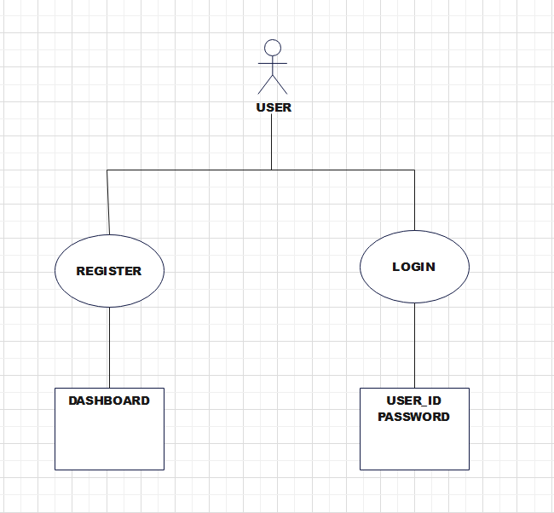

FIG 6.3

**(D) DFD:-**

DataFlow Diagram isthe graphical description of the system’s data and how the processes transform the data. The information flow and the transform that are applied as data move from the input to output. It is starting point of the design phase that functionally decomposes the requirement specifications down to the lowest level of details. Thus a DFD describes what data flow(logical) rather than how they are processed.

Unlike details flowchart, data flow diagram do no supply detailed description of the module but graphically describes a system’s data interact with the system. to construct a dataflow diagram, we use-

* Arrows
* Circles
* Open end box
* Square

An arrow identifies the dataflow in motion. it is a pipeline though which information is flows like the rectangle in the flowchart. A circle stands for process that converts data into information. An open-ended box represents a data store, Data at rest or a temporary repository of data. Square defines a source or destination of system data.

Rule for constructing a data flow diagram

* Arrows should not cross each other.
* Square, circle and file must be name.
* Decomposed data flow square and circle can have same name.
* Choose meaningful names for dataflow.

FIG 6.4 DFD LEVEL 0

FIG 6.5 DFD LEVEL 1

**(E) Activity diagram**

Activity diagram is basically a flow chart to represent the flow form one activity to another activity. The activity can be described as an operation of the system.  It captures the dynamic behavior of the system.

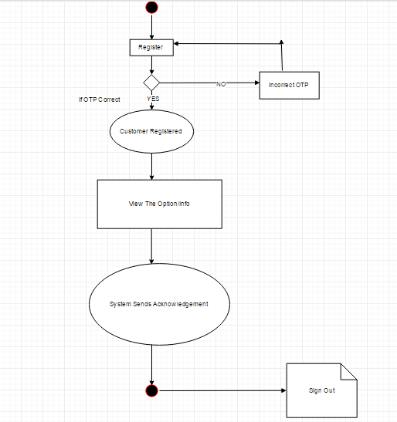

**FIG 6.6**

**7. Future Enhancements:**

The Employee Attrition Prediction System is designed to be easy to maintain and upgrade. In the future, the following features can be added:

* Real-Time Monitoring: Track employee data continuously to provide more accurate and up-to-date predictions.
* Cloud Deployment: Host the system on the cloud for easier access from anywhere.
* Web-Based Application: Convert the system into a web app for better accessibility and convenience.
* Integration with HR Systems: Link the system to existing HR software for automatic data updates.
* Improved Predictions: Use more advanced machine learning models to enhance the accuracy of attrition predictions.

These upgrades will make the system more powerful and accessible for organizations.

1. **Results:**

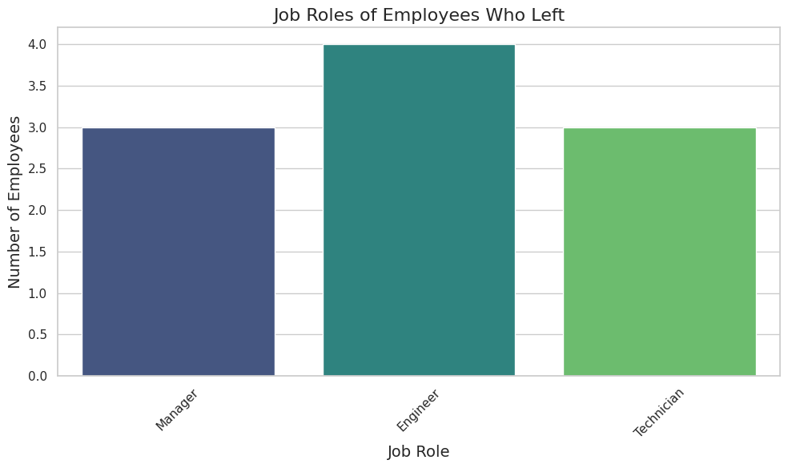

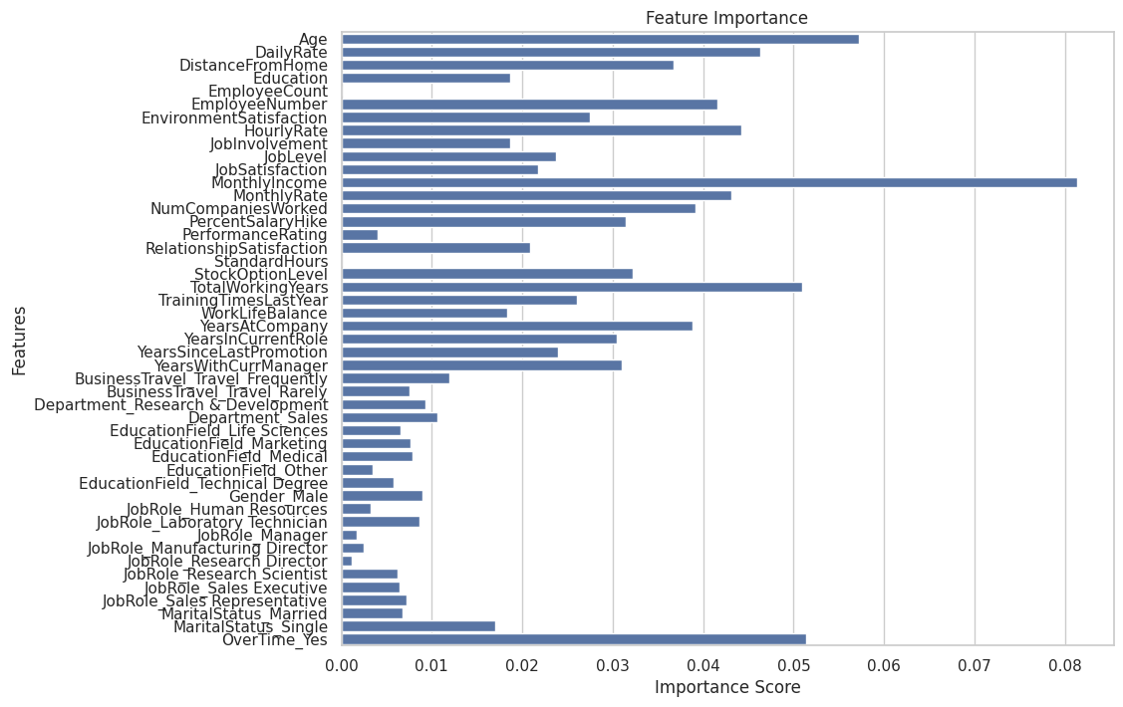

1. **Conclusion:**

Predicting employee attrition is a valuable tool for organizations to proactively manage their workforce and reduce the negative impact of turnover. By analyzing various factors such as job satisfaction, work-life balance, compensation, and management quality, organizations can identify employees at risk of leaving and implement targeted interventions to improve retention.

While predictive models can provide valuable insights, they should not be relied upon solely. Human judgment and qualitative factors remain crucial in understanding and addressing the complex reasons behind employee attrition. By combining data-driven insights with thoughtful management practices, organizations can create a positive work environment that fosters employee engagement, satisfaction, and loyalty.

**10. References**

* [https://www.wikipedia.org](https://www.wikipedia.org/)
* <https://research.google.com/colaboratory/>
* https://www.kaggle.com/
* <https://www.edrawmax.com/>
* <https://www.google.co.in/>